**Session 6 –PSO Report**

**19IM10028 – Shashank Sundi**

**Activity 2.**

1. **Change # of population size: 10:10:50**

n=10 --- obj val =3.502

n=20 --- obj val =0.015

n=30 --- obj val =0.001

n=40 --- obj val =5.29e-04

n=50 --- obj val =3.018e-09

best=50

We can observe that , with increase in population size the best func value approaches closer to 0.Moreover , we also observe from the graphs that with increase in population size , the optimum value is reached at an earlier iteration.

1. **Change inertia weight(W) : 0.1:0.1:0.9**

w=0.1 --- obj val =2.15e-04

w=0.2--- obj val =1.47e-21

w=0.3-- obj val =1.5e-26

w=0.4-- obj val =2.07e-25

w=0.5-- obj val =8.09e-21

w=0.6 --- obj val =7.13e-22

w=0.7 --- obj val =5.7e-21

w=0.8 --- obj val =2.31e-22

w=0.9 --- obj val =8.91e-24

best= 0.3

It is observed that with increase in inertia weight , the algorithm converges faster.All objective values are very close to zero and the difference is not significant.Hence, changing inertia weight has effect only on the speed of convergence and not much on the obj val.

1. **Change the # of iteration :10:10:100**

maxite=10 --- obj val=1.7e-11

maxite=20 --- obj val=0.57e-12

maxite=30 --- obj val=2.905e-16

maxite=40 --- obj val=0.01016

maxite=50 --- obj val=0

maxite=60 --- obj val=3.28e-14

maxite=70 --- obj val=0

maxite=80 --- obj val=2.69e-16

maxite=90 --- obj val=0

maxite=100 --- obj val=0

best=100

The trend on increasing max iterations is a bit random.However, the fitness value mostly decreases with increase in iterations.Although a significant difference is not observed for differwnt iteration values,choosing higher no. of iterations is suggested.

1. **Change the acceleration factor**

**C1 (for Pbest) 0:0.2:1**

C1=0 --- obj val=4.18e-05

C1=0.2 --- obj val=0

C1=0.4 --- obj val=0

C1=0.6 --- obj val=6.956e-08

C1=0.8 --- obj val=6.15e-12

C1=1 --- obj val=0

Best=0.4

With increase in c1 fitness values do not change much significantly .

**C2 (for Gbest) 0:0.2:1**

C2=0 --- obj val=19.95

C2=0.2 --- obj val=0

C2=0.4 --- obj val=1.06e-08

C2=0.6 --- obj val=8.17e-06

C2=0.8 --- obj val=0

C2=1 --- obj val=0

Best=1

With increase in c2 , fitness value decreases.

1. **Comment on what will happened when C1>C2 and C2>C1**

Keeping iters=50, maxrun=2,n=50,w=0.1

c1=0.6 , c2=1 obj val=2.04

c1=1 , c2=0.6 obj val=6.25

So, PSO performs better in case of c2>c1 as compared to c1>c2

1. **Comment on whether run has any effect**

maxrun=2----obj val=3.568

maxrun=4----obj val=0.071

maxrun=6----obj val=7.78e-05

maxrun=8----obj val=2.11e-06

maxrun=10----obj val=0

best=10

We can see that with increase in the no. of runs , the fitness value decreases.Hence a higher no. of runs is preferred

**ACTIVITY 2**

Write a code for adding following two constraints to the objective function **[Code submission required]**

$x_{1}+x_{2 }+x_{3 }≤5$

$x_{1}^{2}+2x_{2 }-x_{3 }≤0$

**Best params**

% Best Parameters taken after the Analysis of Activity 1 for this part

%%PSO Parsms

n=50; % population size

w=0.3; % inertia weight

wdamp = 0.99; % inertia deamping

c1=0.4; % acceleration factor P_best

c2=1; % acceleration factor G_best

maxite=100; % set maximum number of iteration in each run

maxrun=10; % set maximum number of runs need to be

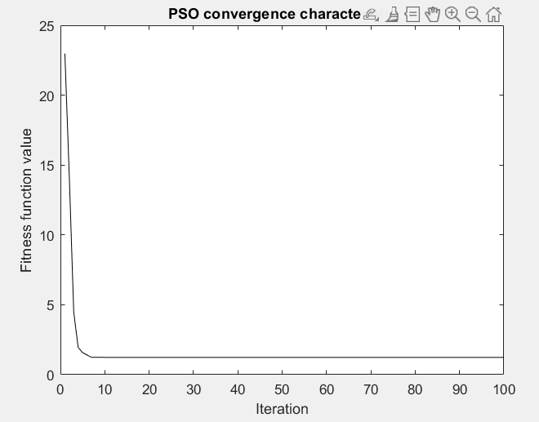

**bestfun =**

**1.236933176100629**

**bestrun =**

**1**

**best_variables =**

**0.938679245587900 1.967499997932440 3.008333334411155**